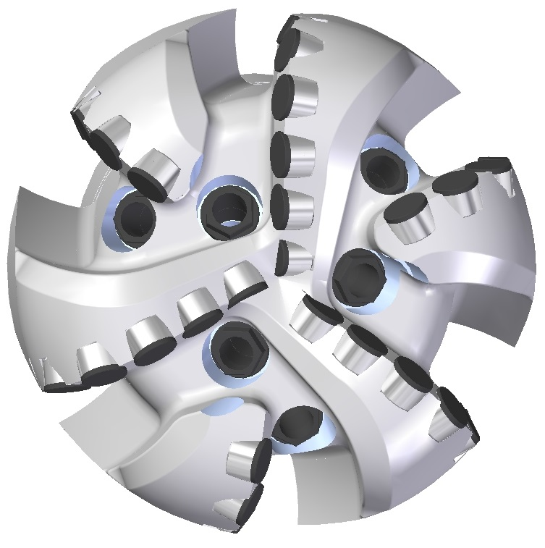 |  | 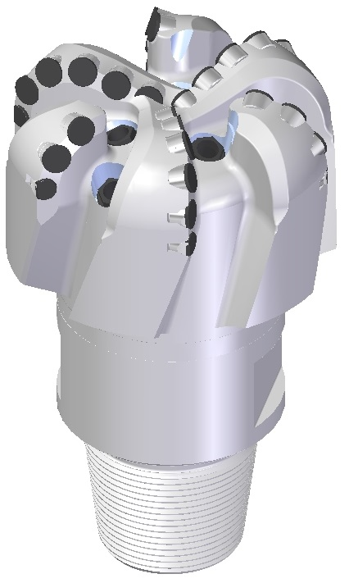

Drill Bit Specifications:
Cutter Size (Primary, Sec) | 3/4”, 5/8”
Cutter Count (Total, Gage) | 29,6
Blade Count | 6
Gage Length (Inches) | 3.40”
Nozzle Count (Primary, Sec.) | 6
Nozzle Size (Primary, Sec.) | 60
JSA (Sq. Inches) | 13.94
Max. TFA (Sq. Inches) | 2.23
Operating Parameters:
Hydraulic Flow Rate (GPM) | 255 - 560
Max. Weight on Bit (1,000 Lbs.) | 25
Make-up Torque (ft/lbs) | 16,488
Nominal Dimensions:
Overall Length (Inches) | 14.22
Make Up Length (Inches) | 10.10
Bit Breaker | SKB-21010
Connection | Ø4-1/2" API Reg.
Approx. Weight (Lbs.) | 89

Standard Features:

- Large open face volume assists cuttings removal
- Six nozzles optimize blade cleaning and cuttings removal
- Premium grade cutters maximize ROP and Life

619-SR Nomenclature Explained:

- 6 = Number of blades
- 19 = Primary Cutter Size (19mm)
- SR = Single Row of Cutters
- 6 = Number of nozzles
Interchangeable nozzles.

